Creating a hello world fastapi application

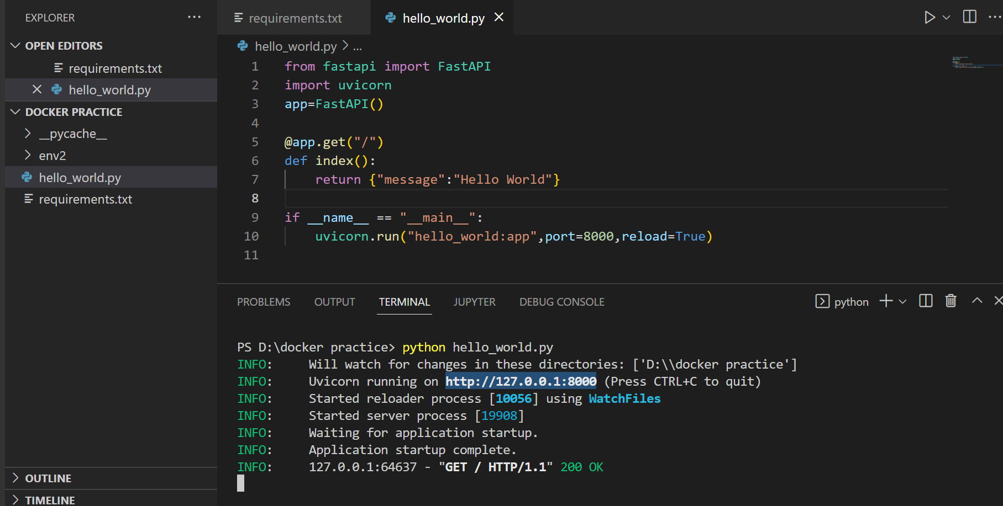

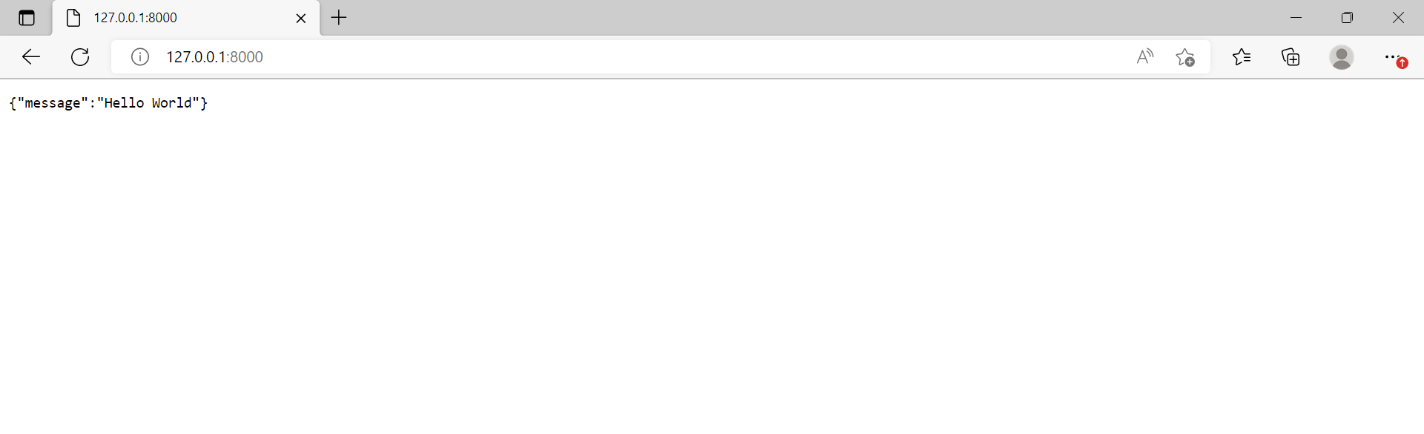

Creating a Dockerfile for fastapi Hello world application

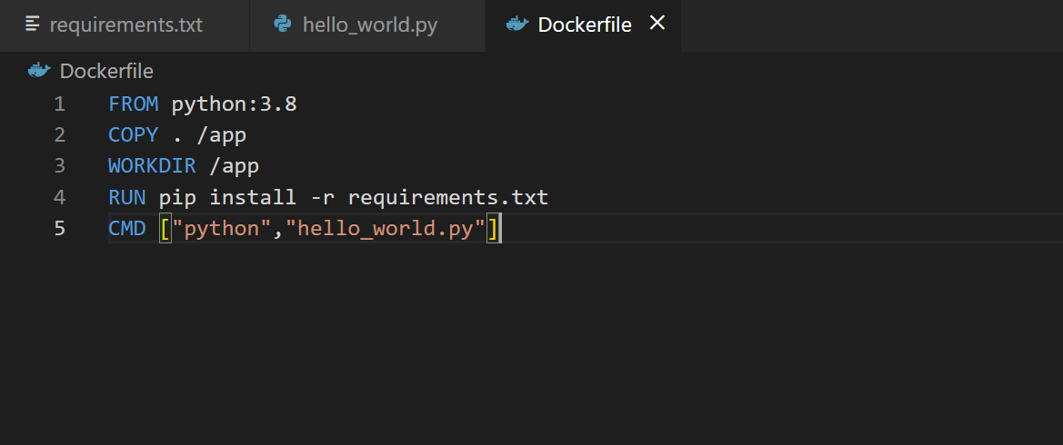

Building a docker image

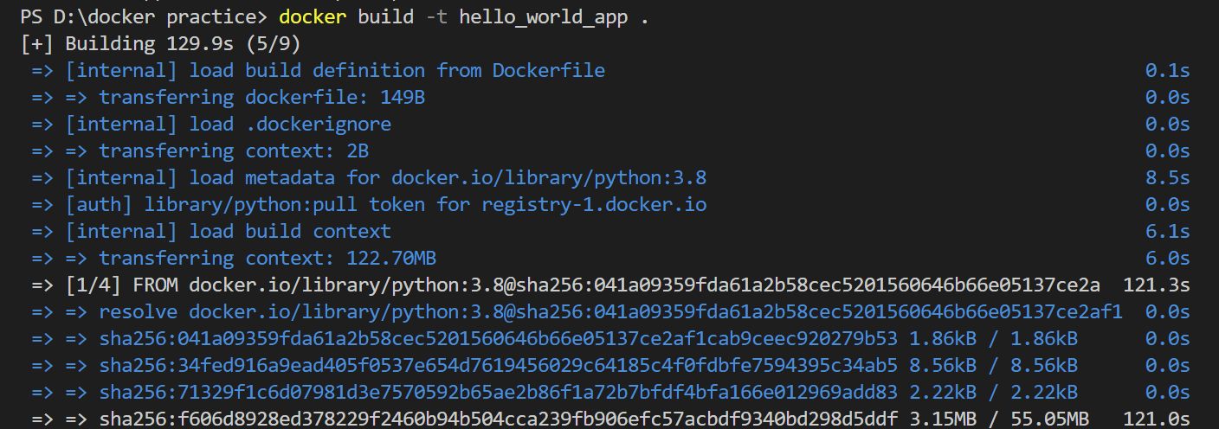

Built docker image using docker file

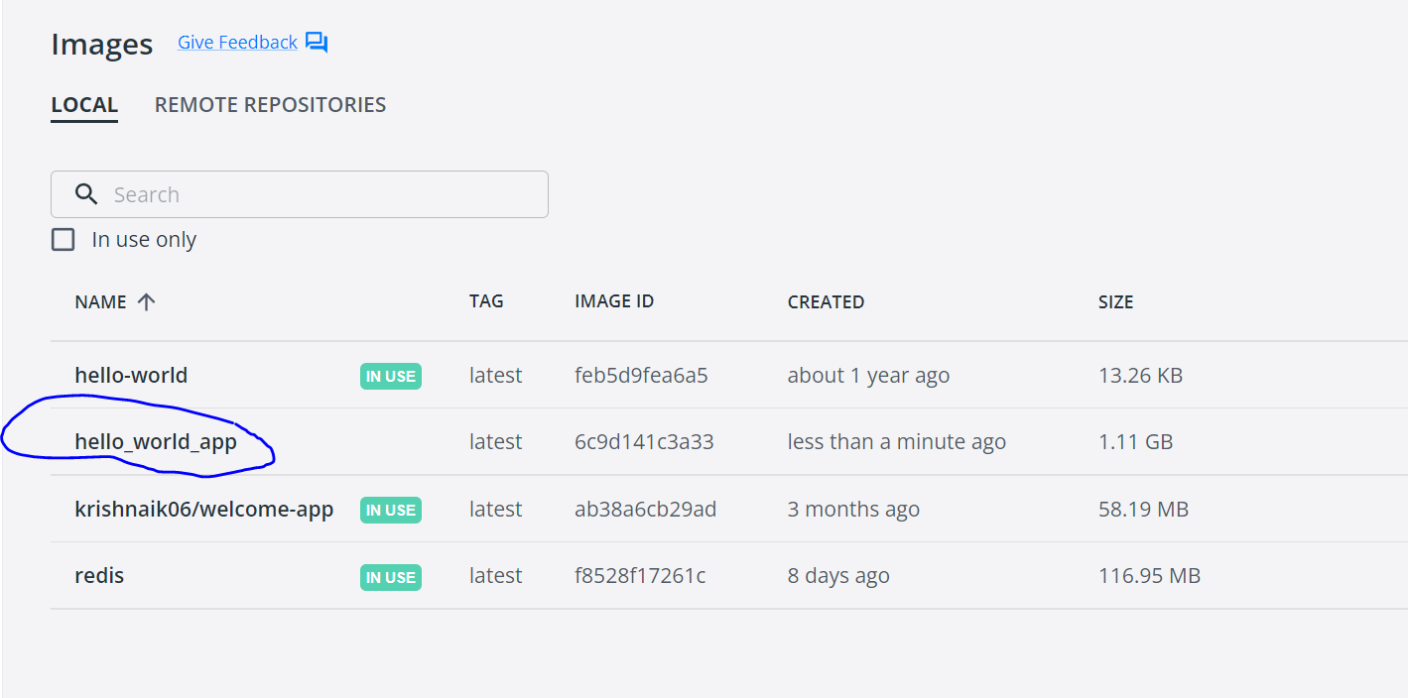

Running docker image and creating a docker container



Pushing docker image to docker hub

